**Conceptual and Logical Designs**

Conceptual Database Design (EER):

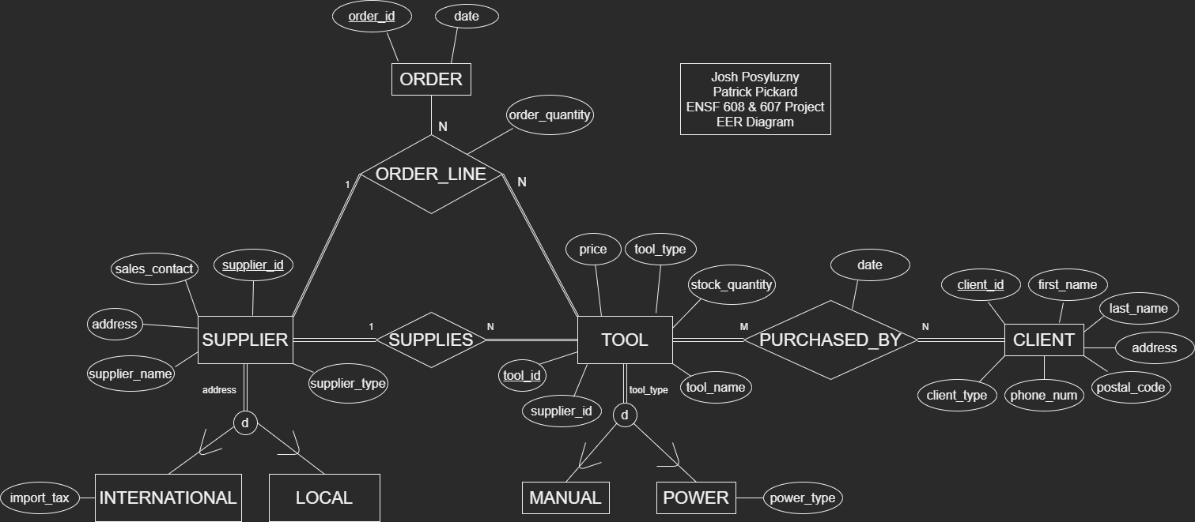

- SUPPLIER has been subclassed into INTERNATIONAL and LOCAL, which is a total participation disjoint relationship, as every SUPPLIER will be either one. A SUPPLIER of LOCAL type will not have any additional attributes, but it still shown in the subclass diagram for visualization of the total disjoint.

- TOOL has been subclassed into MANUAL and POWER, which is a total participation disjoint relationship, as every TOOL will be either one. A TOOL of MANUAL type will not have any additional attributes, but it is still shown in the subclass for visualization of the total disjoint.

- This diagram is built using the assumption that every TOOL only has one SUPPLIER, for simplicity.

- For the SUPPLIES relationship, every TOOL has one SUPPLIER, and every SUPPLIER supplies at least one TOOL.

- For the ORDER_LINE n-ary relationship:

- Every ORDER composed will have an order_id number, a tool_id number, a supplier_id number, and an order quantity for the TOOL. Since each TOOL is supplied by only one SUPPLIER, ORDER_LINE to SUPPLIER holds a 1 for cardinality.

- Not every ORDER will have an order line (maybe we didn’t sell enough TOOLs), but every

SUPPLIER will be able to receive an ORDER, and every TOOL will be available for ORDER.

- For the PURCHASED_BY M-N relationship:

- Every CLIENT will have purchased at least one TOOL, and every TOOL can be purchased by any

number of CLIENTs.

Logical Database Design (Relational Model):

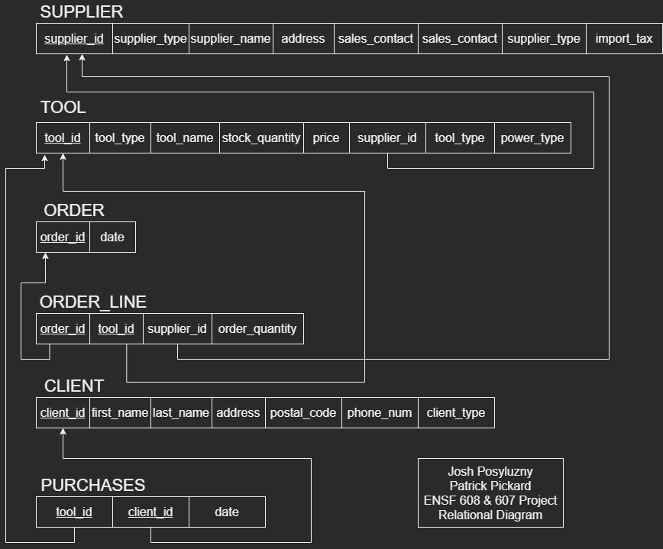

- SUPPLIER and TOOL will be subclassed according to option c from the lecture notes.

- Since ORDER_LINE is an n-ary relationship, it will hold primary keys of order_id and tool_id, and since each TOOL can only be supplied by one SUPPLIER, supplier_id is not a primary key, as it will always be unique.

- The PURCHASES M-N relationship will hold the primary keys of the entities that it is connecting as foreign keys, which are tool_id and client_id.